Task Description #1 (Password Strength Validator – Apply AI in
Security Context)
• Task: Apply AI to generate at least 3 assert test cases for
is_strong_password(password) and implement the validator
function.
• Requirements:
o Password must have at least 8 characters.
o Must include uppercase, lowercase, digit, and special
character.
o Must not contain spaces.
Example Assert Test Cases:
assert is_strong_password(&quot;Abcd@123&quot;) == True
assert is_strong_password(&quot;abcd123&quot;) == False
assert is_strong_password(&quot;ABCD@1234&quot;) == True
Expected Output #1:
• Password validation logic passing all AI-generated test cases.\
PROMPT: Generate a Python is_strong_password(password) function that validates passwords using these rules: minimum 8 characters, at least one uppercase letter, lowercase letter, digit, special character, and no spaces. Also provide at least 3 assert test cases and ensure they all pass.
CODE: def is_strong_password(password):
return (
len(password) >= 8
and any(char.isupper() for char in password)
and any(char.islower() for char in password)
and any(char.isdigit() for char in password)
and any(not char.isalnum() and not char.isspace() for char in password)
and not any(char.isspace() for char in password)
)

assert is_strong_password("Strong1!")
assert is_strong_password("Python3@Code")
assert not is_strong_password("weakpass")
assert not is_strong_password("Strong 1!")

print("All password validation test cases passed!.")
OUTPUT: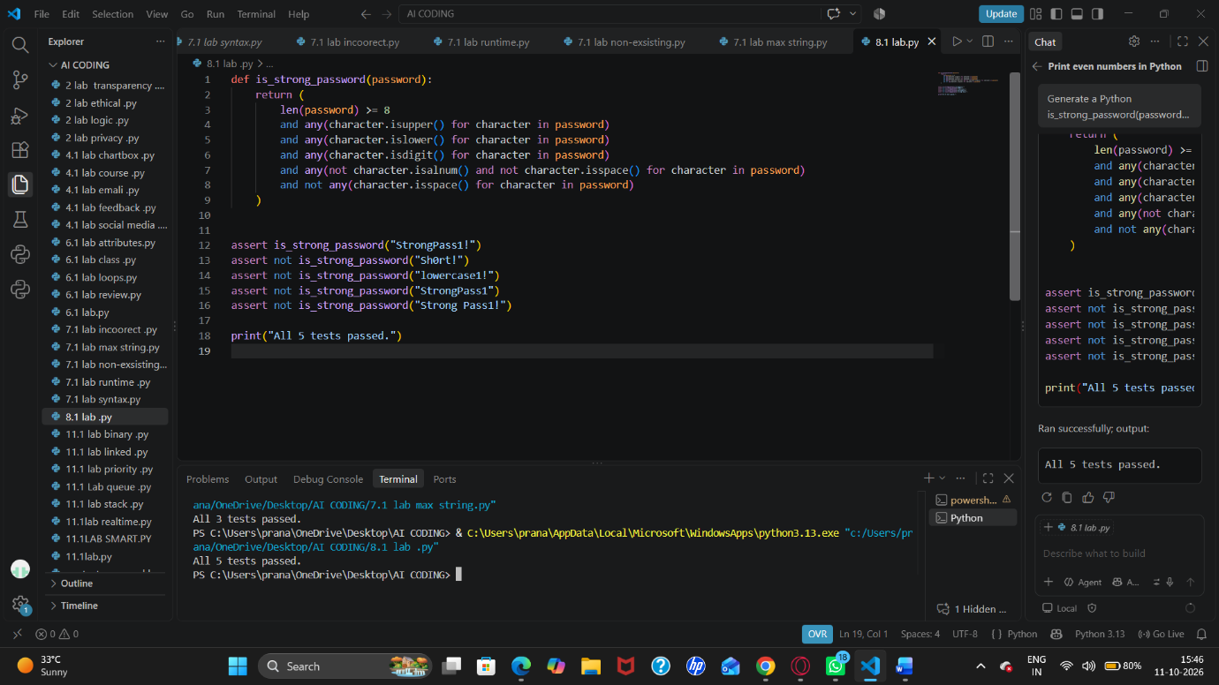

Task Description #2 (Number Classification with Loops – Apply
AI for Edge Case Handling)
• Task: Use AI to generate at least 3 assert test cases for a
classify_number(n) function. Implement using loops.
• Requirements:
o Classify numbers as Positive, Negative, or Zero.
o Handle invalid inputs like strings and None.
o Include boundary conditions (-1, 0, 1).
Example Assert Test Cases:
assert classify_number(10) == &quot;Positive&quot;
assert classify_number(-5) == &quot;Negative&quot;
assert classify_number(0) == &quot;Zero&quot;
Expected Output #2:
• Classification logic passing all assert tests.
PROMPT: Generate a Python function classify_number(n) that classifies a number as "Positive", "Negative", or "Zero". Use loops in the implementation, handle invalid inputs such as strings and None, and test boundary values -1, 0, and 1. Provide at least 3 assert test cases and ensure all tests pass.
CODE: def classify_number(n):
if n is None or isinstance(n, bool) or not isinstance(n, (int, float)):
raise TypeError("Input must be a number")

for value in (n,):
if value > 0:
return "Positive"
if value < 0:
return "Negative"

return "Zero"

assert classify_number(-1) == "Negative"
assert classify_number(0) == "Zero"
assert classify_number(1) == "Positive"

try:
classify_number("5")
assert False
except TypeError:
pass

try:
classify_number(None)
assert False
except TypeError:
pass

print("All number classification tests passed!")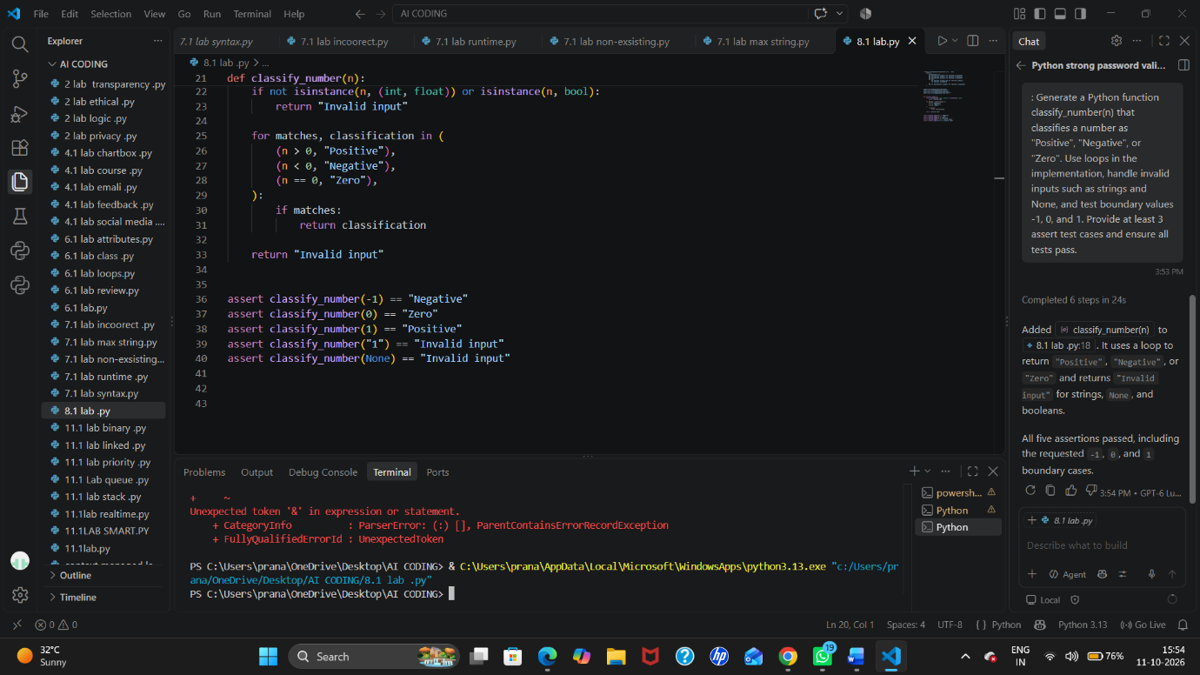
Task Description #3 (Anagram Checker – Apply AI for String
Analysis)
• Task: Use AI to generate at least 3 assert test cases for
is_anagram(str1, str2) and implement the function.
• Requirements:
o Ignore case, spaces, and punctuation.
o Handle edge cases (empty strings, identical words).
Example Assert Test Cases:
assert is_anagram(&quot;listen&quot;, &quot;silent&quot;) == True
assert is_anagram(&quot;hello&quot;, &quot;world&quot;) == False
assert is_anagram(&quot;Dormitory&quot;, &quot;Dirty Room&quot;) == True
Expected Output #3:
• Function correctly identifying anagrams and passing all AI-
generated tests.
PROMPT: Generate a Python function is_anagram(str1, str2) that checks whether two strings are anagrams. Ignore case, spaces, and punctuation when comparing them. Handle edge cases such as empty strings and identical words. Provide at least 3 assert test cases, including valid and invalid anagrams, and ensure all tests pass.
CODE: def is_anagram(str1, str2):
if not isinstance(str1, str) or not isinstance(str2, str):
raise TypeError("Both inputs must be strings")

cleaned_str1 = sorted(char.lower() for char in str1 if char.isalnum())
cleaned_str2 = sorted(char.lower() for char in str2 if char.isalnum())

return cleaned_str1 == cleaned_str2

assert is_anagram("listen", "silent")
assert is_anagram("Dormitory", "Dirty room!!")
assert is_anagram("", "")
assert is_anagram("Python", "Python")
assert not is_anagram("hello", "world")

print("All anagram test cases passed!")

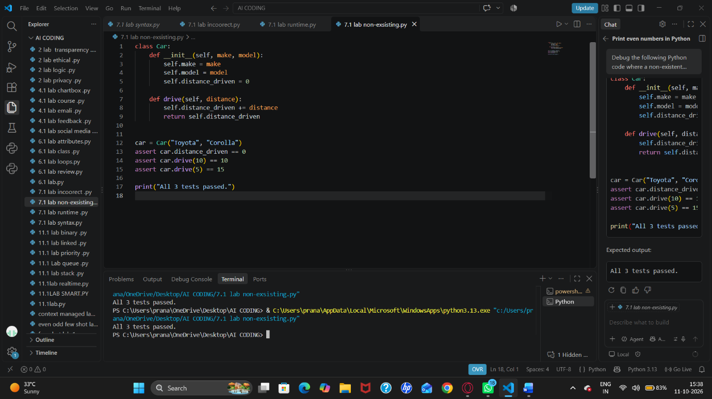

Task Description #4 (Inventory Class – Apply AI to Simulate Real-
World Inventory System)
• Task: Ask AI to generate at least 3 assert-based tests for an
Inventory class with stock management.
• Methods:

o add_item(name, quantity)
o remove_item(name, quantity)
o get_stock(name)
Example Assert Test Cases:
inv = Inventory()
inv.add_item(&quot;Pen&quot;, 10)
assert inv.get_stock(&quot;Pen&quot;) == 10
inv.remove_item(&quot;Pen&quot;, 5)
assert inv.get_stock(&quot;Pen&quot;) == 5
inv.add_item(&quot;Book&quot;, 3)
assert inv.get_stock(&quot;Book&quot;) == 3
Expected Output #4:
• Fully functional class passing all assertions.
PROMPT: Generate a Python Inventory class for managing stock with these methods: add_item(name, quantity), remove_item(name, quantity), and get_stock(name). Include proper handling for adding, removing, and checking stock. Provide at least 3 assert-based test cases covering normal operations and edge cases, and ensure all assertions pass.
CODE: class Inventory:
def __init__(self):
self.stock = {}

def add_item(self, name, quantity):
self._validate(name, quantity)
self.stock[name] = self.stock.get(name, 0) + quantity

def remove_item(self, name, quantity):
self._validate(name, quantity)

if self.stock.get(name, 0) < quantity:
raise ValueError("Insufficient stock")

self.stock[name] -= quantity

def get_stock(self, name):
if not isinstance(name, str) or not name.strip():
raise ValueError("Item name must be non-empty")

return self.stock.get(name, 0)

@staticmethod
def _validate(name, quantity):
if not isinstance(name, str) or not name.strip():
raise ValueError("Item name must be non-empty")
if isinstance(quantity, bool) or not isinstance(quantity, int) or quantity <= 0:
raise ValueError("Quantity must be a positive integer")

inventory = Inventory()

inventory.add_item("Book", 10)
assert inventory.get_stock("Book") == 10

inventory.add_item("Book", 5)
assert inventory.get_stock("Book") == 15

inventory.remove_item("Book", 3)
assert inventory.get_stock("Book") == 12

assert inventory.get_stock("Pen") == 0

try:
inventory.remove_item("Book", 20)
assert False
except ValueError:
pass

print("All inventory tests passed!")
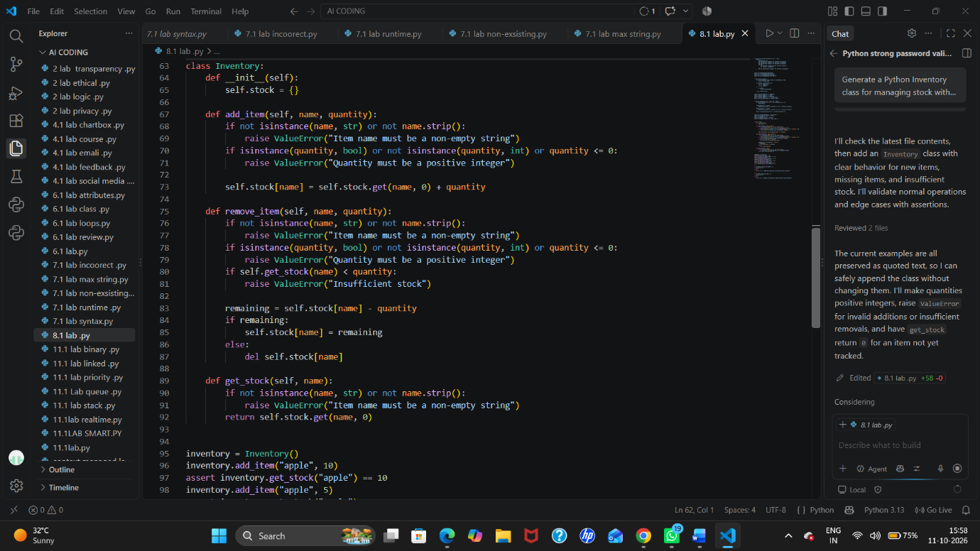

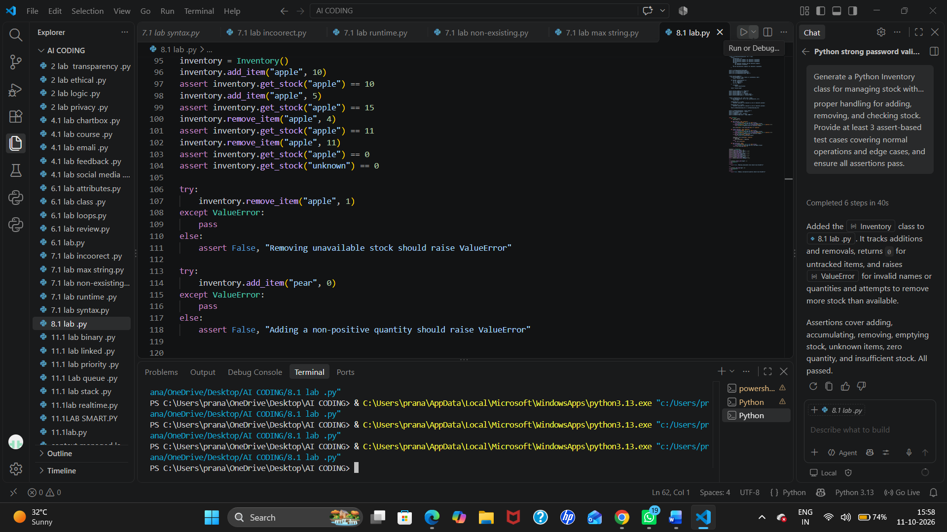

Task Description #5 (Date Validation &amp; Formatting – Apply AI for
Data Validation)
• Task: Use AI to generate at least 3 assert test cases for
validate_and_format_date(date_str) to check and convert
dates.
• Requirements:
o Validate &quot;MM/DD/YYYY&quot; format.
o Handle invalid dates.
o Convert valid dates to &quot;YYYY-MM-DD&quot;.
Example Assert Test Cases:
assert validate_and_format_date(&quot;10/15/2023&quot;) == &quot;2023-10-15&quot;
assert validate_and_format_date(&quot;02/30/2023&quot;) == &quot;Invalid Date&quot;
assert validate_and_format_date(&quot;01/01/2024&quot;) == &quot;2024-01-01&quot;
Expected Output #5:
• Function passes all AI-generated assertions and handles edge
cases.
PROMPT: Generate a Python function validate_and_format_date(date_str) that validates dates in MM/DD/YYYY format, handles invalid dates, and converts valid dates to YYYY-MM-DD format. Include at least 3 assert test cases covering valid dates, invalid dates, and edge cases such as leap years. Ensure all assertions pass.
CODE: from datetime import datetime
import re

def validate_and_format_date(date_str):
if not isinstance(date_str, str) or not re.fullmatch(r"\d{2}/\d{2}/\d{4}", date_str):
raise ValueError("Date must use MM/DD/YYYY format")

try:
date = datetime.strptime(date_str, "%m/%d/%Y")
except ValueError as error:
raise ValueError("Invalid date") from error

return date.strftime("%Y-%m-%d")

assert validate_and_format_date("01/15/2024") == "2024-01-15"
assert validate_and_format_date("02/29/2024") == "2024-02-29"
assert validate_and_format_date("12/31/2023") == "2023-12-31"

try:
validate_and_format_date("02/29/2023")
assert False
except ValueError:
pass

try:
validate_and_format_date("13/01/2024")
assert False
except ValueError:
pass

print("All date validation tests passed!")